Tyrik Edwards

CTEC 298

Tableau Plot

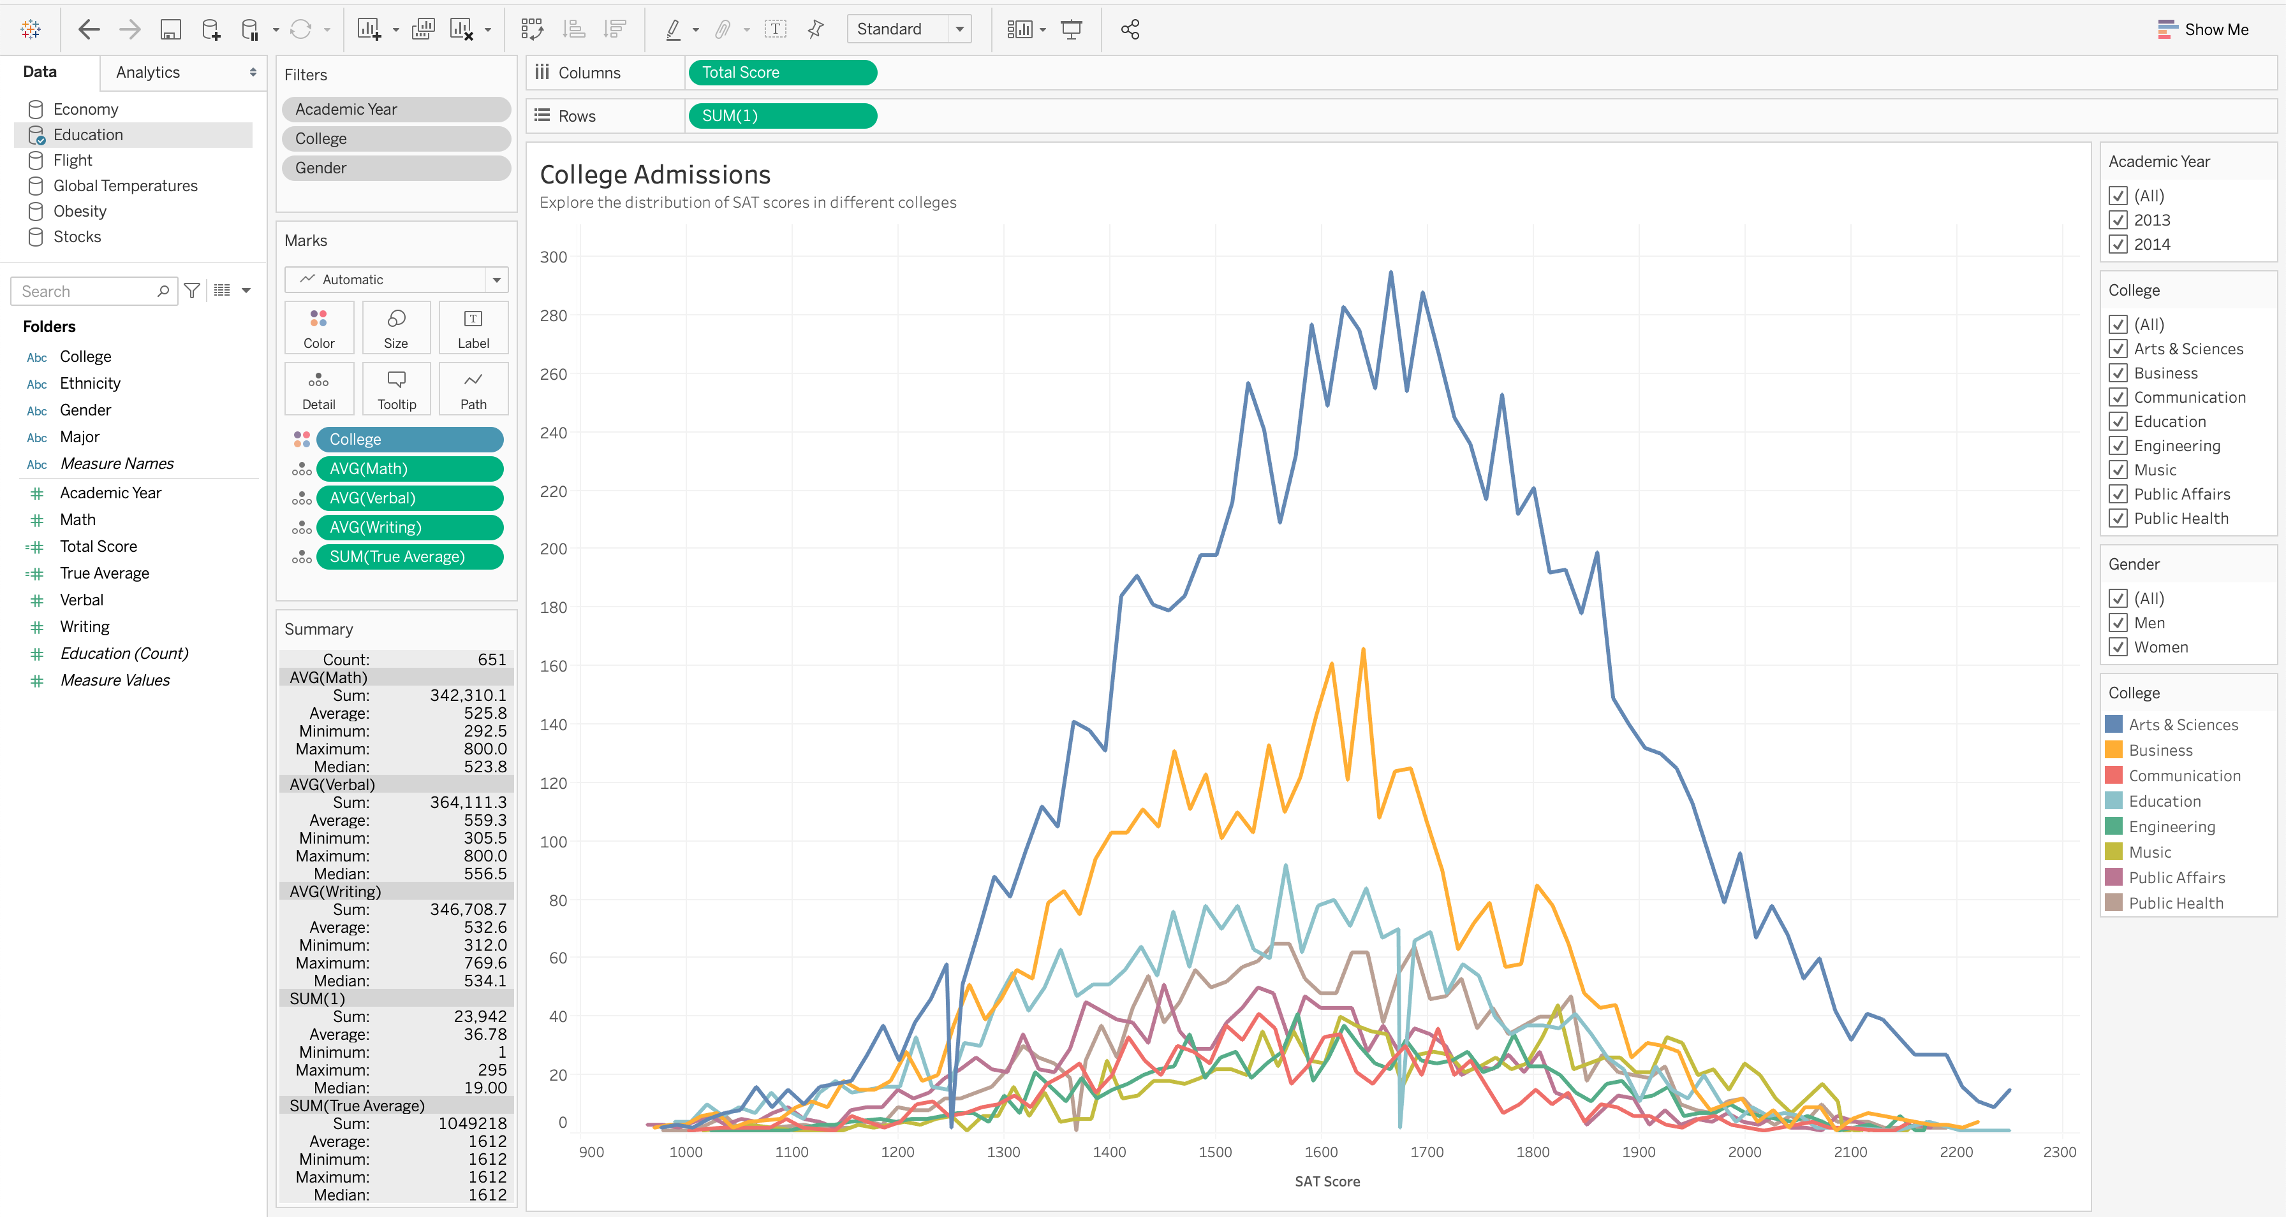

Line Plot

This Line plot shows the SAT scores of different colleges. The lines depicting rate of change make it very easy for the human eye to compare rates of change over time or, *trends*. These time series analyses are also useful when comparing trends between categories. As you can see to the right it shows the academic years which are 2013, 2014, different colleges and gender. On the X axis it shows the range of SAT score and the Y axis shows the range of 0 – 300.

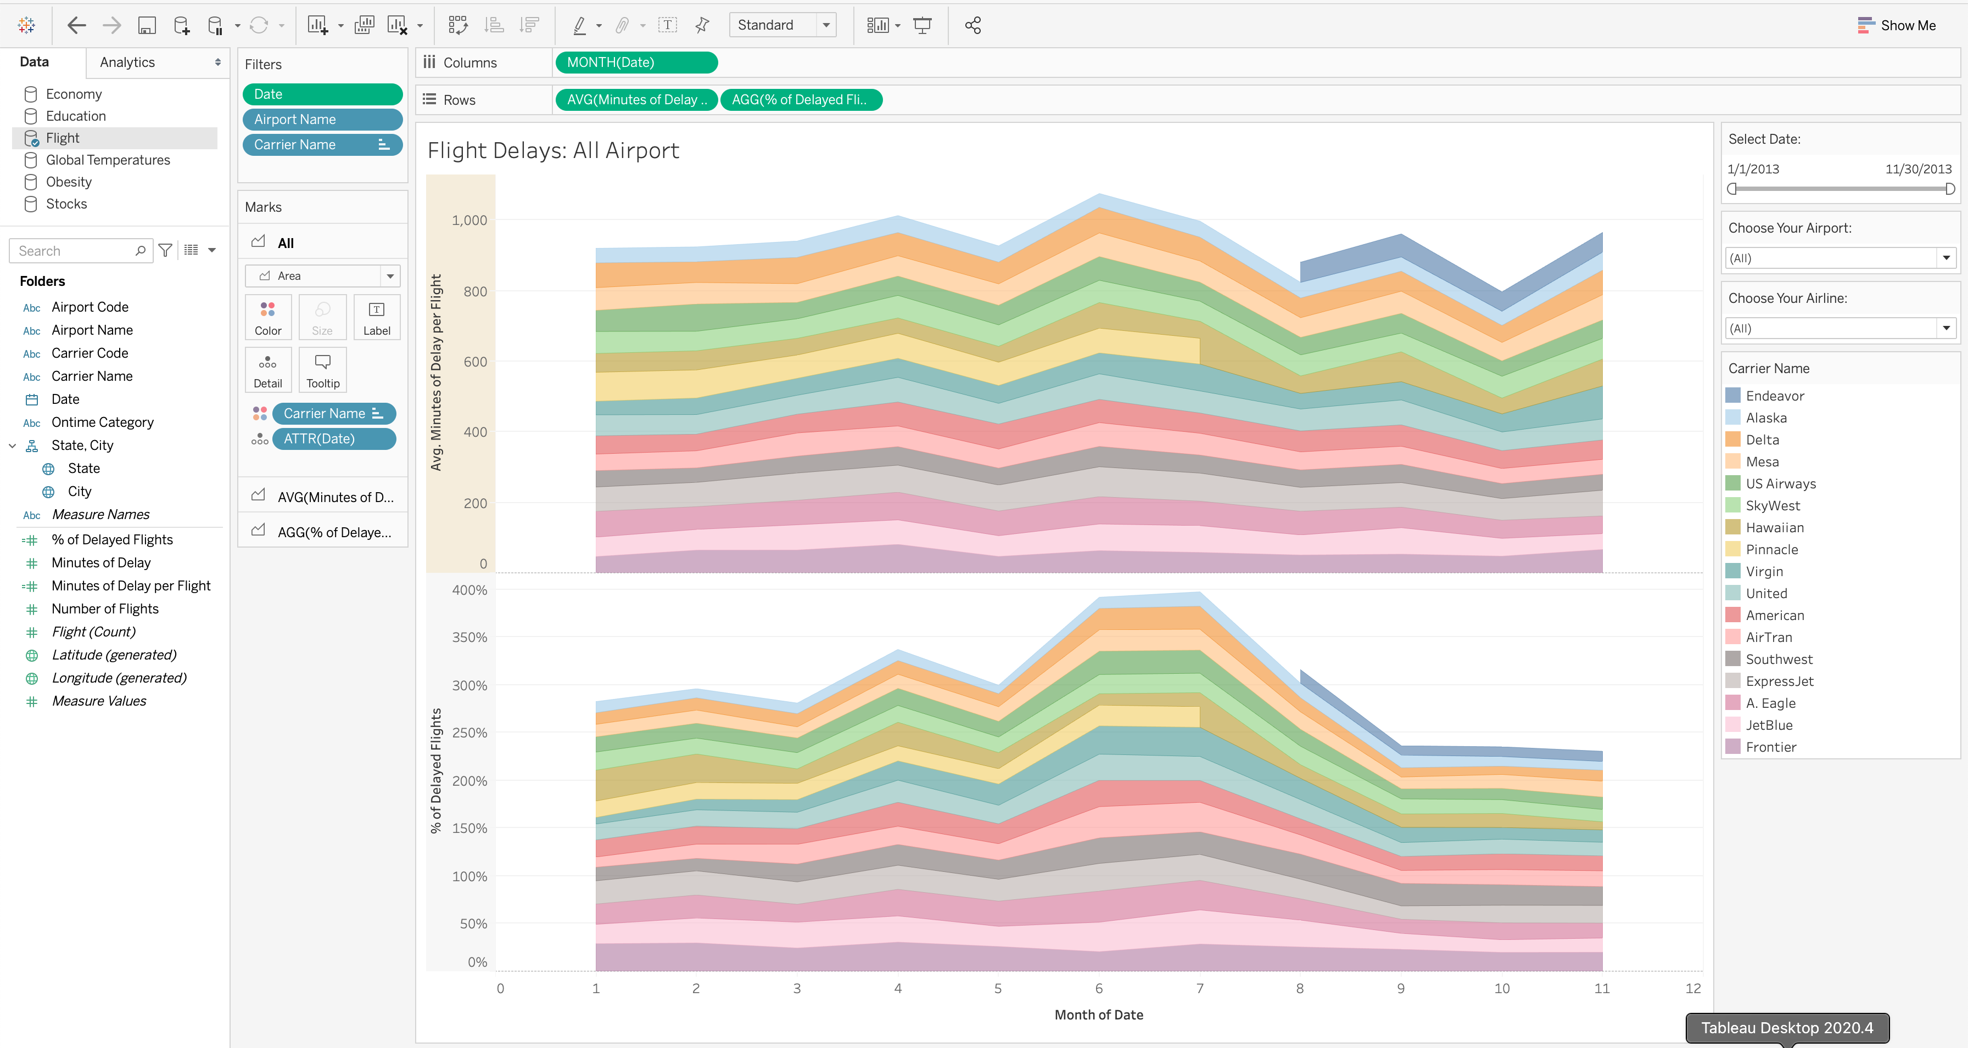

Area Plot

This is an area plot for Flight delays at airports. Showing the rise and fall of various data series over time. Showing change over time in individual panels of a small multiple chart

They are categorized by airline and airport and you can filter by the dates and the different airlines. On the X – Axis there are the months of the year. On the Y- Axis there is the percentage of delayed flights and the average minutes per flight.